HOW TO INSTALL USB DRIVER
- Disable driver signature enforcement(part B) before install driver(WIN10 only).
- Connect the meter with PC by usb Cable
- Power on the meter
- Open inf-wizard.exe and click ‘Next’ button.
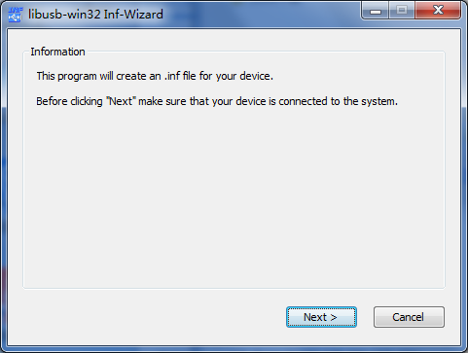
- Select ‘0x0483 0xDF11 IE606 DFU’ item then click ‘Next’ button.
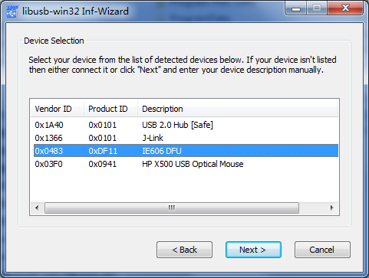
- Click ‘Next’ button.
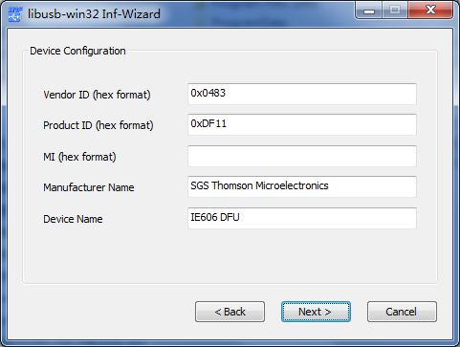
- Create a new folder to save the driver file and click ‘Install Now..’ button.
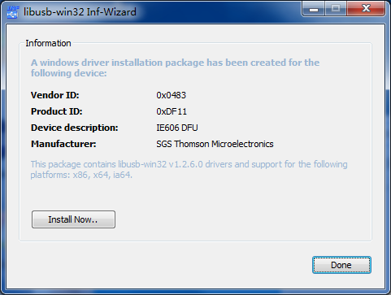
- Wait for the driver to be installed then click ‘Ok’ button.
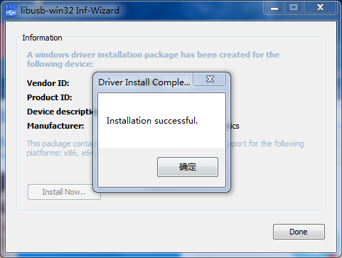

Part B: Disable Signed Driver Enforcement on Windows 10.
How can I install drivers that are not digitally signed?
Windows 10 enforces driver signatures by default. This can be disabled to install drivers that are not digitally signed. Use the following steps to disable driver signature enforcement.
- Click the Start menu and select Settings.
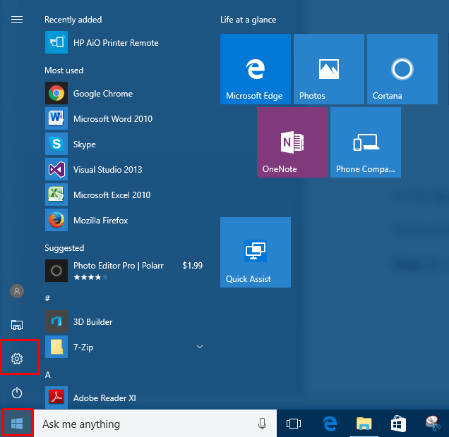
- Click Update and Security.
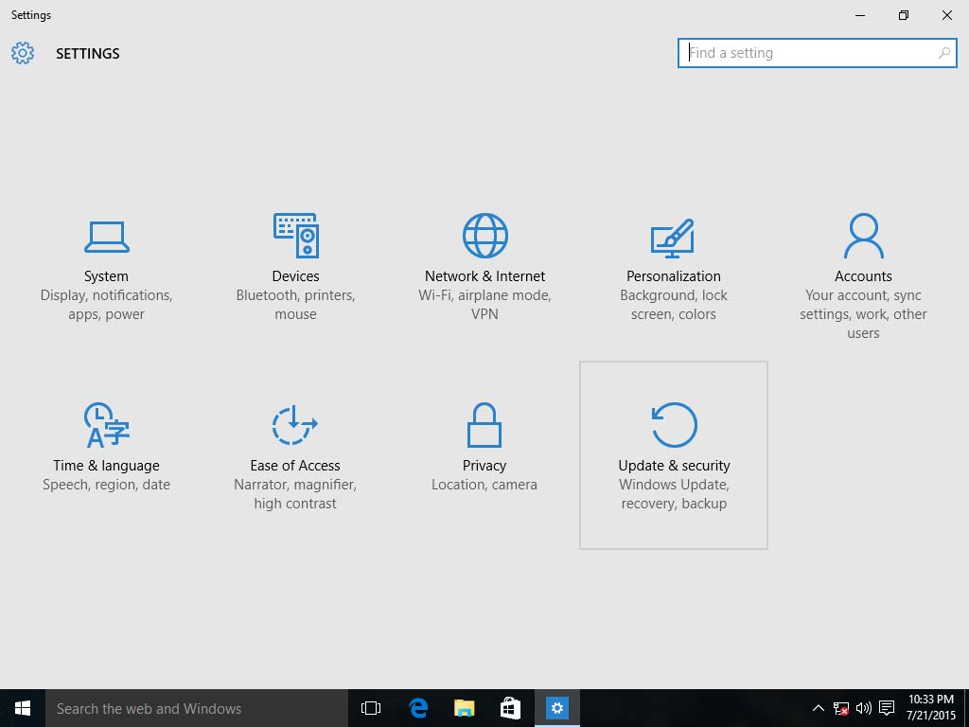
- Click on Recovery.
4. Click Restart now under Advanced Startup.
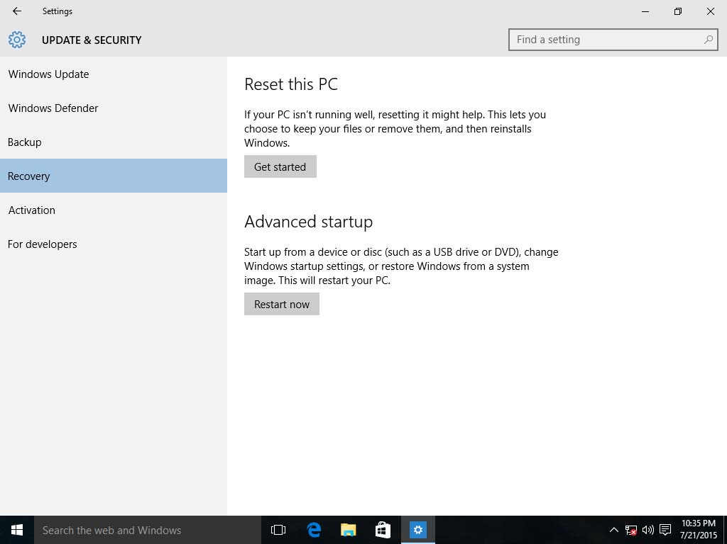
- Click Troubleshoot.
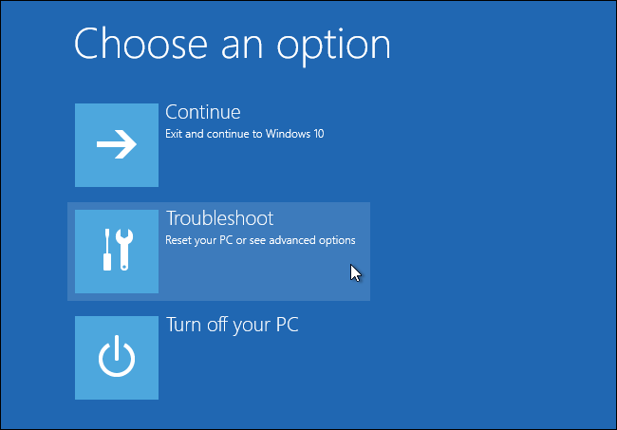
- Click Advanced options.
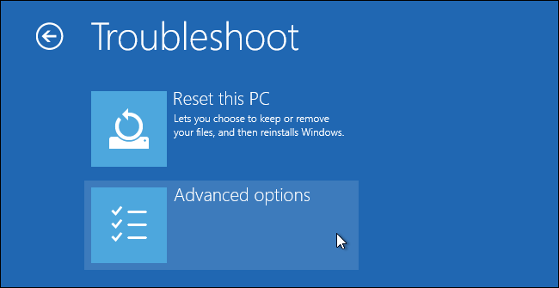
7. Click Startup Settings.
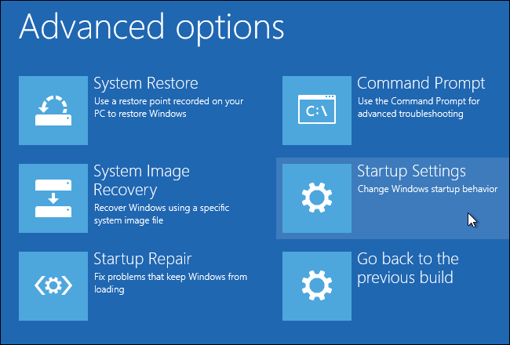
8. Click on Restart.
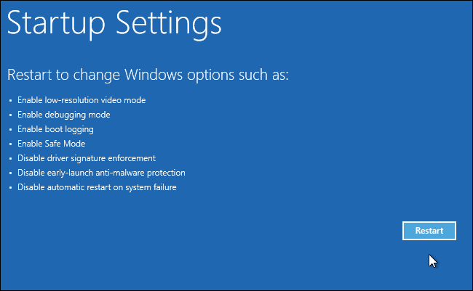
- On the Startup Settings screen press 7 to disable driver signature enforcement.
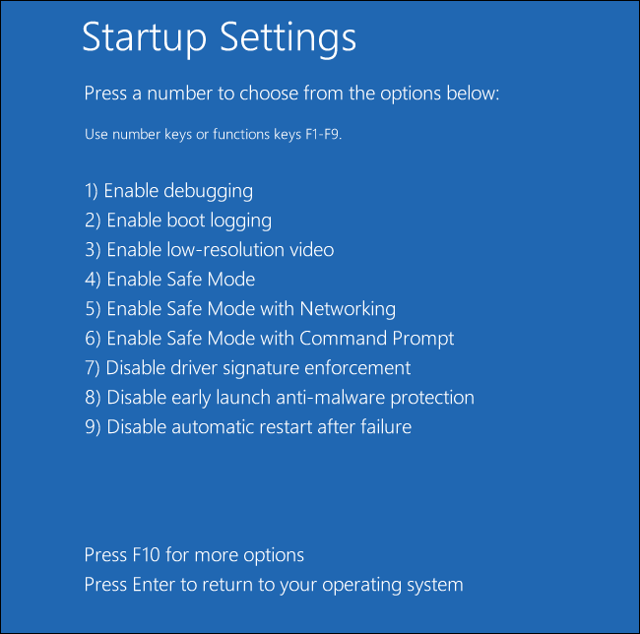
Your computer will restart and you will be able to install non-digitally signed drivers. If you restart your computer again the driver signature enforcement will be re-enabled.

